Behind the Algorithm: Risk, Ethics, and the Governance of AI in Business and Society

AI Risk Analysis:

Introduction
Artificial Intelligence (AI) is transforming society and industries in a powerful way, from shaping business decisions to impacting finance, healthcare, education, and governance. While AI opens amazing possibilities, it also up brings new, unpredictable risks which are rapidly evolving. Traditional governance systems, are designed for more stable technologies, are struggling to keep up with these fast-changing challenges. My report dives deeply into the main risks associated with AI, explores why current governance models often missing the mark, and highlights innovative, more effective approaches to managing AI risks in a way that is both responsible and ethical.

Understanding AI Risks: A Comprehensive Overview
AI systems come with a range of potential risks. Unlike older technologies, AI often makes decisions based on complex and massive datasets and algorithms that, in many cases, even the creators might not completely understand. A closer look at recent research highlights four main categories of risks associated with AI.
- Technical Risks:
Technical risks are related to how AI systems function works. Problems such as biased training data, errors in algorithms, or unpredictable behaviours can cause serious failures. As Amodei et al. (2016) point out, AI models can be quite fragile small and tiny changes in the input data can leads to drastically different, and sometimes harmful results.
- Ethical Risks:
Ethical concern focuses on how AI can reinforce unfairness and bias. As O'Neil (2016) puts it, "algorithms are opinions embedded in code," which means they often carry the same biases as the data which they’re trained on. Few examples, like facial recognition systems misidentifying people of colour more frequently (Buolamwini and Gebru, 2018), highlight how AI can unintentionally deepen social inequalities.
- Societal Risks:
On a very large scale, AI has significant effects in society, which might influence everything from jobs to privacy and even democracy. companies use AI to gather large amount of personal data, often without proper consent, which raising serious concerns about privacy and the control people have over their own information.
- Business Risks:
For businesses, AI can bring significant financial, legal, and reputational risks. Poor governance of AI systems, which can lead to public scandals, legal consequences, and damaged consumer trust (Reputation) as seen in the fallout from the Cambridge Analytica data misuse (Isaak and Hanna, 2018).
What makes AI risks particularly challenging is the way these categories overlap and influence one another, creating a complex web of interconnected issues.
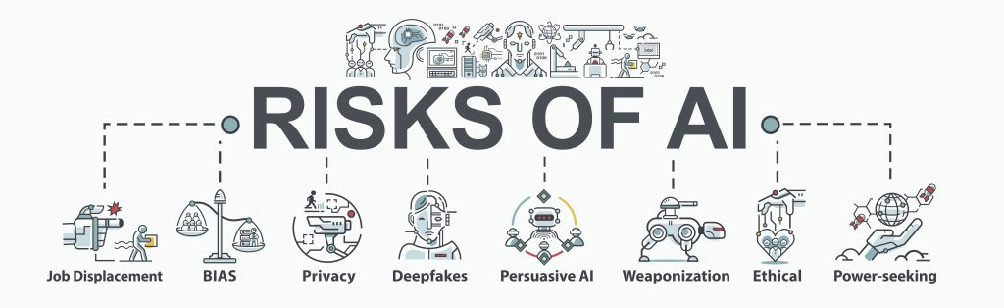

Challenges in Governing AI Risks
Managing the risks of AI is bit more complicated than regulating older technologies. A big challenge is that the issue of regulatory lag: while AI is advancing at enormous speed, by creating new laws and policies is a slow and often very slow and complex process (Calo, 2017). By the time new regulations are taking, they’re often already outdated.
Another issue is that the reliance on softer governance methods, like ethical guidelines and voluntary standards, which really don’t have the power to make a real change. Wagner (2018) refers to this as "ethics washing," where majority of companies talk about the importance of ethical AI but often fails to take meaningful action.
Finally, AI's global nature complicates the things further, where systems deployed in different countries may face entirely different legal requirements as per their regulations. This can create confusion about who will be taken responsibility when things gone wrong.
Overall, the traditional top-down approach for regulation is no longer enough for AI technology. What’s needed is a more flexible, adaptive model of governance to effectively manage the risks which AI brings.

New Directions: Innovative Approaches to AI Governance
As the challenges of regulating AI become clearer several forward-thinking strategies are emerging:
- Blended Governance Models
The more adaptable approach combines traditional regulations as per industry standards and ethical guidelines. For instance, the European Commission’s proposed AI Act uses a risk-based model, meaning AI systems are regulated according to the level of harm they could potentially cause (European Commission, 2021).

- Algorithmic Impact Assessments (AIAs)
Inspired from environmental impact assessments, Algorithmic Impact Assessments (AIAs) helps the organizations proactively consider the ethical and social consequences of their AI systems before they’re deployed (Reisman et al., 2018).

- Audits and Certifications
Individual audits became more essential to ensure AI systems are fair enough, transparent, and accountable. For example, the AI Now Institute recommends regular third-party audits, particularly for high-risk AI applications (AI Now, 2018).

- Ethics by Design
Rather than considering ethics as an afterthought, "ethics by design" makes sure that ethical considerations are built into the development process from the start. This approach includes forming diversified teams, creating transparent models, and managing data responsibly (Jobin, Ienca, and Vayena, 2019).

- Public Participation
There’s increase in support for involving the public in AI governance, such as Methods like citizen juries, public consultations, and participatory policymaking could help to ensure that AI systems better reflect the values and needs for the society (Cath et al., 2018).
Together, these approaches signal a shift in AI governance towards a system which is faster, more collaborative, and places ethical considerations and societal impact more deeply embedded in how AI technologies

Conclusion
AI is no longer a futuristic idea it’s already shaping our world, and its risks are real and growing. Issues like technical failures, ethical dilemmas, social disruptions, and business vulnerabilities all these issues highlights the need for more adaptable and intelligent governance models. To manage these risks effectively, we need a mixture of regulation, independent oversight, and public participation also. The future of AI governance must be as dynamic and innovative as the technology itself, ensuring AI is used in ways which are safe, fair, and in aligned with human values.

